 

**5GZORRO**

Grant Agreement 871533

H2020 Call identifier: H2020-ICT-2019-2  
Topic: ICT-20-2019-2020 - 5G Long Term Evolution

D6.1: Dissemination, Communication and Standardization Plan

|  |  |  |
| --- | --- | --- |
| **Dissemination Level** | | |
|  | PU | Public |
|  | CO | Confidential, only for members of the consortium (including the Commission Services) |
|  | CI | Classified, information as referred to in Commission Decision 2001/844/EC |

**Intermediate version. Pending of EC revision. Do not cite.**

|  |  |  |
| --- | --- | --- |
| Grant Agreement no:  **871533** | Project Acronym:  **5GZORRO** | Project title:  **Zero-touch security and trust for ubiquitous computing and connectivity in 5G networks.** |

|  |  |
| --- | --- |
| Lead Beneficiary:  **Ubiwhere** | Document version:  **V1.0** |

|  |
| --- |
| Work package:  **WP6 – Impact Creation** |

|  |
| --- |
| Deliverable title:  **D6.1:** **Dissemination, Communication and Standardization Plan** |

|  |  |  |
| --- | --- | --- |
| Start date of the project:  **01.Nov.2019**  **(duration 30 months)** | Contractual delivery date:  **31.Jan.2020** | Actual delivery date:  **3.Feb.2020** |

|  |
| --- |
| **Editor(s)**  Pedro Diogo (Ubiwhere) |

**List of Contributors**

|  |  |  |
| --- | --- | --- |
| Participant | Short Name | Contributor |
| Ubiwhere | UW | Pedro Diogo, Marta Lima |
| Comunicare Digitale | CODI | Carla Bressan, Andrea Michelozzi |
| Fundació I2cat | i2CAT | Javier Fernández Hidalgo, Shuaib Siddiqui, August Betzler |
| Nextworks | NXW | Gino Carrozzo, Juan Brenes |
| Telefonica I+D | TID | Diego Lopez |
| Fondazione Bruno Kessler | FBK | Tejas Subramanya |
| Univ. De Murcia | UMU | Gregorio Martinez Perez, José María Jorquera |
| BARTR HOLDINGS Ltd | BARTR | Paul Handerson, Martyn Taylor, James Taylor |
| Altice Labs | ALTICE | José Bonnet |
| Intracom Telecom | ICOM | Marinela Mertiri, Marievi Xezonaki |
| Atos Spain | ATOS | Aurora Ramos |
| Malta Comm. Authority | MCA | Antoine Sciberras |
| IBM Israel | IBM | Katherine Barabash |

**List of Reviewers**

|  |  |  |
| --- | --- | --- |
| Participant | Short Name | Contributor |
| Nextworks | NXW | Gino Carrozzo |
| I2CAT | I2CAT | Shuaib Siddiqui, Jose Miguel Sanjuan |

**Change History**

|  |  |  |  |
| --- | --- | --- | --- |
| Version | Date | Partners | Description/Comments |
| 0.0 | 16-12-190 | UW | Initial ToC |
| 0.1 | 15-01-20 | CODI, UMU, FBK, I2CAT, NXW, ALB | Contributions in various sections |
| 0.2 | 27-01-20 | UW | Integration of other contributions from partners |
| 0.4 | 30-01-20 | UW | Finalization of document |
| 0.5 | 31-01-20 | NXW, i2CAT | Quality Check review |
| 1.0 | 03-02.20 | UW | Final version ready for submission |

**DISCLAIMER OF WARRANTIES**

This document has been prepared by 5GZORRO project partners as an account of work carried out within the framework of the contract no 871533.

Neither Project Coordinator, nor any signatory party of 5GZORRO Project Consortium Agreement, nor any person acting on behalf of any of them:

* makes any warranty or representation whatsoever, express or implied,
  + with respect to the use of any information, apparatus, method, process, or similar item disclosed in this document, including merchantability and fitness for a particular purpose, or
  + that such use does not infringe on or interfere with privately owned rights, including any party's intellectual property, or
* that this document is suitable to any particular user's circumstance; or
* assumes responsibility for any damages or other liability whatsoever (including any consequential damages, even if Project Coordinator or any representative of a signatory party of the 5GZORRO Project Consortium Agreement, has been advised of the possibility of such damages) resulting from your selection or use of this document or any information, apparatus, method, process, or similar item disclosed in this document.

5GZORRO has received funding from the European Union’s Horizon 2020 research and innovation programme under grant agreement No 871533. The content of this deliverable does not reflect the official opinion of the European Union. Responsibility for the information and views expressed in the deliverable lies entirely with the author(s).

**Table of Contents**

Executive Summary 7

1. Introduction 8

2. Communication Plan 9

2.1. Communication Tools 9

2.1.1. Project Website 9

2.1.2. Social Media 11

2.1.3. Webinars 13

2.1.4. Other Branding Material 15

2.2. Project Communication Material 17

2.2.1. Flyer 17

2.2.2. Roll-up and Posters 17

2.2.3. Promotional Video 17

2.3. Press Releases & News 17

2.4. Blog 19

2.5. Newsletter 20

3. Dissemination Plan 21

3.1. Open access policy 26

3.2. Collaboration within 5G PPP and other projects 26

3.3. Individual dissemination plans 27

3.3.1. Altice Labs (ALTICE) 27

3.3.2. ATOS Spain (ATOS) 27

3.3.3. BARTR HOLDINGS Ltd (BARTR) 27

3.3.4. Communicare Digitale (CODI) 28

3.3.5. Fondazione Bruno Kessler (FBK) 28

3.3.6. Fundació I2CAT (i2CAT) 28

3.3.7. IBM Israel (IBM) 28

3.3.8. Intracom Telecom (ICOM) 28

3.3.9. Malta Communications Authority (MCA) 29

3.3.10. Nextworks (NXW) 29

3.3.11. Telefonica I+D (TID) 29

3.3.12. Ubiwhere 30

3.3.13. Univ. De Murcia (UMU) 30

4. Plans towards Standards and Open Source communities 31

5. Conclusions 33

6. Abbreviations and Definitions 34

6.1. Abbreviations 34

6.2. Definitions 34

**List of Tables**

Table 1 – Plan for 5GZORRO Press Releases 17

Table 2 – Plan for blog post contributions in 2020 19

Table 3 – Events with potential 5GZORRO presence with dissemination activities 22

Table 4 – 5GZORRO collaborations within 5G PPP area 26

Table 5 – SDOs/SSOs & Open-source communities / projects 31

**List of Figures**

Figure 1 - 5GZORRO Official Logo 9

Figure 2 – 5GZORRO Project Website, Home page 10

Figure 3 – 5GZORRO Project Website, News section 10

Figure 4 – 5GZORRO Project Website, Links to external channels and initiatives. 11

Figure 5 - 5GZORRO Twitter account 12

Figure 6 - 5GZORRO LinkedIn Account 13

Figure 7 – 5GZORRO Webinar Simulation 14

Figure 8 - Presentation Template 15

Figure 9 - Flyer Template 15

Figure 10 - Poster Template 16

Figure 11 - Webinar Template 16

Executive Summary

5GZORRO is a 5G PPP Phase 3 research project working on zero-touch security and trust solutions for ubiquitous computing and connectivity in 5G networks.

The 5GZORRO Consortium envisions a truly production-level 5G network, in which many pervasive and shared resources (spectrum, virtualized radio access, virtualized edge/core) can coexist through automated end-to-end network slicing, with security and trust, across multiple operators and different infrastructure resource providers. 5GZORRO uses distributed Artificial Intelligence (AI) to implement cognitive network orchestration and management with minimal manual intervention (Zero-Touch Automation). To implement flexible and efficient distributed security and trust across the various parties involved a 5G end-to-end service, 5GZORRO uses Distributed Ledger Technologies (DLT).

Due to the nature of this planned research, the 5GZORRO Consortium assigns high importance to all the actions aimed at generating awareness and visibility to the results of the project, both within the scientific community working on 5G and among the large set of involved stakeholders (network industry, network operators, Verticals, regulators, SMEs, etc.). The WP6 – Impact Creation – is the workpackage responsible for this part of work in the project.

This deliverable D6.1 contains the initial dissemination plan that will be used as guideline during the project to achieve impact in terms of dissemination, communication and standardization. The document also contains a report of the first actions that have been undertaken in the first months of the project to generate awareness, and those planned for implementation in short term, i.e. during the first year of the project. All the activities listed in this document have been discussed with all partners of the Consortium, who have contributed at different levels to: *(i)* identification of scientific and industrial events, *(ii)* selection of the most appropriate standardisation bodies and open-source communities and projects to which the Consortium can contribute, *(iii)* individual dissemination plans.

This dissemination, communication and standardization plan will be regularly reviewed and adjusted internally by the Consortium to adapt to the project execution, the availability of results and to achieve the KPIs set for these activities both globally and per period. In the future deliverable D6.2 (“Intermediate Dissemination and Communication Report”, to be issued in April 2021 – M18) a public update of the plan will be produced together with the report of activities executed in the first period. Through D6.2 the Consortium aims to set the strategy and a detailed action plan for the final 12 months of the project.

# Introduction

This Deliverable 6.1 - “Dissemination, Communication and Standardization Plan”, covers four main areas of the impact achievement strategy for 5GZORRO:

* Communication Plan – Section 2 in which we have identified tools to support communication activities and a plan to periodically and consistently release blog posts and newsletters. In this section we also report on the set-up/implementation of them;
* Dissemination plan – Section 3, which lists a set of target events, conferences and exhibitions of interest for project dissemination. Joint and individual dissemination plans are reported, which highlight the actions planned by the partners to disseminate the project results. These derive from both the joint strategy for impact achievement and the respective areas of research/business;
* Standardisation activities – Section 4, which contains a preliminary plan to target and/or influence standardisation bodies and other relevant open-source based projects with 5GZORRO innovative outcomes;

These core planned activities and scheduling are key to ensure a positive outreach of the project, ultimately facilitating the process of potential exploitation, by different industry sectors and/or enhanced work by the academia. It is crucial to disseminate the findings of such innovative actions, in order to foster more innovation, feed positive synergies which may accelerate development and implementation and, for specific industry partners, market competitiveness.

To effectively implement the set of activities hereby presented, a set of tools and digital frameworks to be used by the consortium are also described.

# Communication Plan

The website is the main channel for communication of project information. Social media are also key valuable channels through which we will spread information on the project, announce news, and create a wide audience active on the research topics of the project.

This section reports on the communication tools which have been established to implement project communication and lists a series of activities planned to populate the communication channels with project information. Details on how to acknowledge the different dissemination actions and other considerations can be found in D1.1 Project Handbook and Management Guidelines. At the base of all the planned activities, there is the project branding and identity. The 5GZORRO project logo has been created with the objective to strengthen the projects communication and dissemination, to recall the key research topics on security and multi-party automated interaction, in order to ease the way our project can be identified and distinguished in the community.

The official project logo for 5GZORRO project is shown in Figure 1.

Figure - 5GZORRO Official Logo

## Communication Tools

### Project Website

The 5GZORRO website has a relevant role in dissemination & communication activities, because it has been designed to work as a “dissemination and promotion” hub and give public access to several outreach materials, starting from the technical specification and reports (i.e. project deliverables, white papers, etc.) and extending to press releases, blogs, videos, news on events and activities taken in major international conferences and exhibitions (e.g. demos, booths, presentations, etc.).

The 5GZORRO website has been designed and launched by the end of Nov. 2019 and is available online at the URL: <http://www.5gzorro.eu/> .

All the information about the project´s activities (past, on-going, upcoming), developments, and results will be accessible from the 5GZORRO website. The site covers project’s description (i.e. Use cases, Architecture, Deliverables), News, Blog and a Gallery section. Also, all public dissemination material (i.e. presentations, flyers, press releases, etc.) have a dedicated section of the website from which they will be made available for download once finalized and presented/published. Where not differently specified, the generic communication material contained in the website is licensed via a Creative Commons license (likely the “CC BY” license) for maximum dissemination and use.

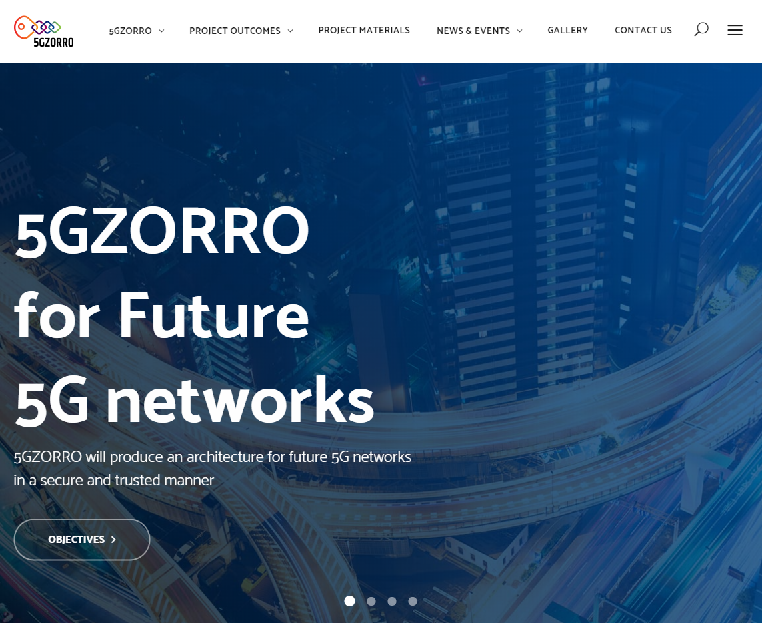

Figure – 5GZORRO Project Website, Home page

The website contains also links to social media channels configured for the project and to relevant external sites (e.g. 5G PPP). In the future it is planned to add also links to software repositories.

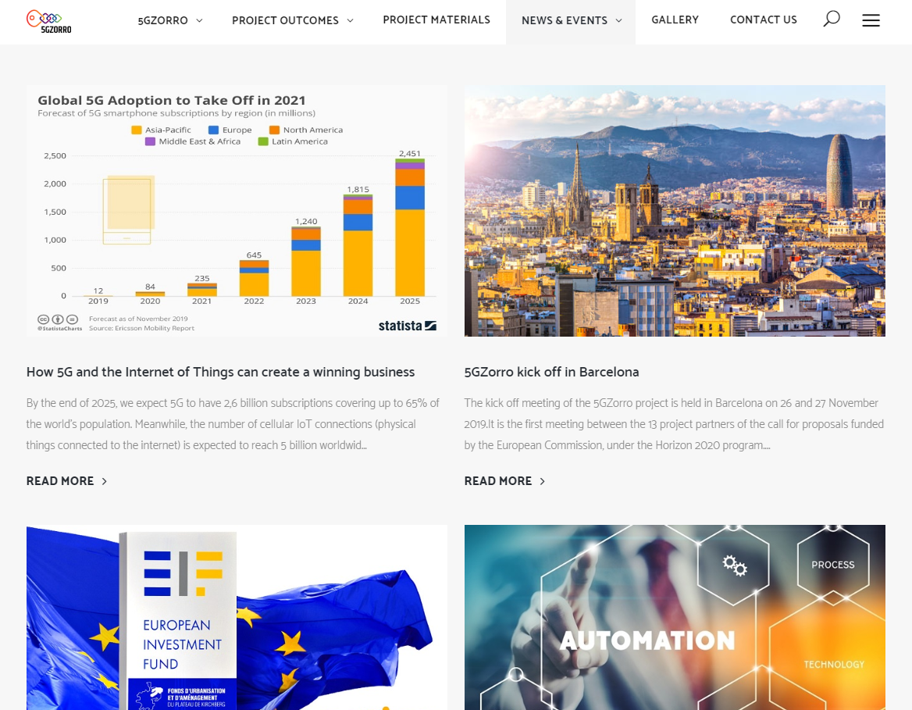

Figure – 5GZORRO Project Website, News section

The project partner’s involvement is very important in amplifying the various activities put in place, in order to generate a fundamental push to receive great attention and consideration on the future collaborations, documents, events and information released.

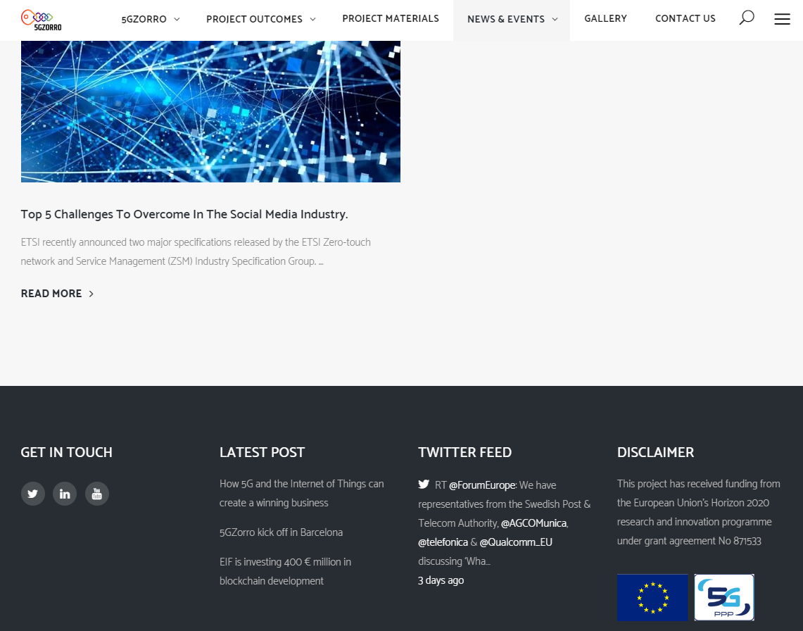

Figure – 5GZORRO Project Website, Links to external channels and initiatives.

To measure the number of visitors and relative metrics on 5GZORRO website, a web traffic analysis tool based on Google analytics has been configured. It also gives detailed information such as users flow and preferences, geographic and demographic information.

The content of the website will be continuously updated during the execution of the project, in order to become a dynamic and up-to-date source of information for the visitors. Even the static pages will be regularly updated to e.g. capture refinements and progress on architecture specification, use cases etc.

### Social Media

A set of 5GZORRO social media channels particularly relevant to communication of research and innovation actions has been activated to guarantee and provide an effective communication and dissemination of project’s results:

* **Twitter (@5Gzorro)**: Twitter is the most immediate and effective tool to communicate live news, events and achievements of the project. It allows to keep the 5GZORRO partner organization, the 5G community, media and the large public of followers of specific trending topics informed and involved. Twitter allows the project to release information effectively, thanks also to the periodicity of activities which in turn generate interest and help to "extend the network" through followers and retweets, thus opening new contacts, relationships, knowledge, information and opportunities.

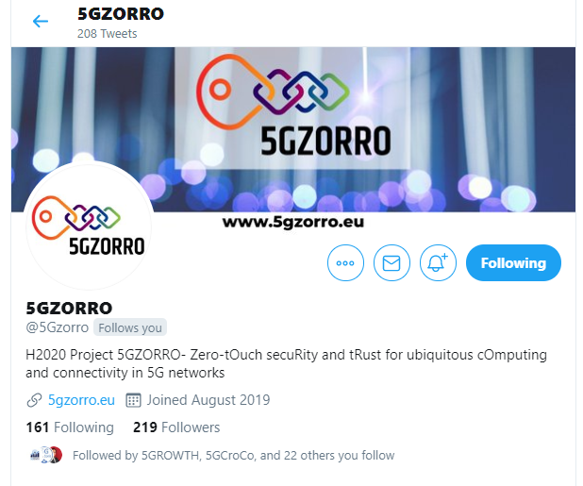

Figure - 5GZORRO Twitter account

A total amount of 219 followers have been reached in 5GZORRO twitter profile by the end of January 2020 (i.e. less than 75 days from account creation).

* **LinkedIn (**<https://www.linkedin.com/company/5gzorro/>**)**: to implement a more effective strategy of communication through LinkedIn, a 5GZORRO “company” profile has been created in order to implement an easier and more direct link of followers to project activities than what it could be possible with a LinkedIn group. The company account will have periodic updates and will establish with other groups connected to 5G, as well as companies, opinion leaders, the press and stakeholders, always with the aim of broadening their audience and highlighting the capacities expressed by the consortium and project.

Figure - 5GZORRO LinkedIn Account

* **YouTube:** a channel will be created to host relevant 5GZORRO webinars, videos and interviews. The first video to be programmed will be shown at the MWC2020, in English, to illustrate the concept, goals and the different use cases.

### Webinars

In order to make sure the innovative outcomes of the project are correctly shared and disseminated with the scientific community and relevant industry, a good amount of effort will go into public 5GOZORRO live Webinars. Given the innovative actions planned for the whole duration of the project and the disruptive potential such outcomes may have on well-established industries such as Telecom and the whole regulation approach in this area, 5GZORRO intends to transparently demonstrate how core technology such as DLTs (Distributed Ledger Technologies) and proven 5G technology, namely SDN and NFV, may greatly enhance and impact the overall 5G ecosystem and stakeholders’ business model (MNOs, Service Providers from different Verticals, Infrastructure owners and Regulators). Paired by AI and ML, 5GZORRO hopes to further advance the most recent efforts on Zero touch network service management, aligned also with standardization efforts by ETSI ZSM. For all this, the live and public webinars will be focused on:

* *Zero touch network & Service Management (alignment with ETSI ZSM) –* how core technologies such as SDN and NFV will form the basis of fully automated, autonomous and self-aware network management and orchestration systems, across different domains
* *Distributed Ledger Technologies (DLTs) and Smart Contracts –* how DLTs are crucial for the Telco sector, providing its ability to program business logic and enforce specific rules which are transparently applied to and by different participants of this network
* *Security, trust and data lakes* *–* how the concept of trusted computing made available by Trusted Execution Environments (TEE) and secure data lakes will aid in the end-to-end security chain and sharing of data across different stakeholders

All of the envisioned webinars will be publicly available and streamed live to platforms such as Twitter and YouTube, with recordings being also available for later consumption in the latter. For better and broader audience participation and engagement, these webinars will be properly announced through 5GZORRO social media, so interested attendees can book in advance and prepare potential questions which may be asked during Q&A (Questions and Answers) session (15 final minutes of every webinar). Furthermore, a dedicated page will be created in the project’s official website, listing all future webinars and previous ones, with links the recorded streams. In parallel, the consortium is evaluating the possibility of leveraging Gleam (<https://gleam.io>) to actively build marketing-like campaigns to ensure 5GZORRO followers (Twitter and LinkedIn) will be notified of upcoming Webinars and also as an incentive for them to also share such announcements, so that 5GZORRO can reach as much people as possible and, thus, disseminate the project’s findings and innovative actions.

The Consortium has agreed to use open-source tools for this live streaming to different platforms. The OBS application (<https://obsproject.com/>) has been selected as the most suitable one. Below is the template and a screenshot of this same application, depicting the result of such streams: speaker (or speakers) will always be visible with a dedicated are to showcase slides and / or any other content from their own laptop. The taken screenshot illustrates what attendees would see, when 5GZORRO broadcasts such webinars live via different channels such as YouTube and Twitter (both at the same time).

1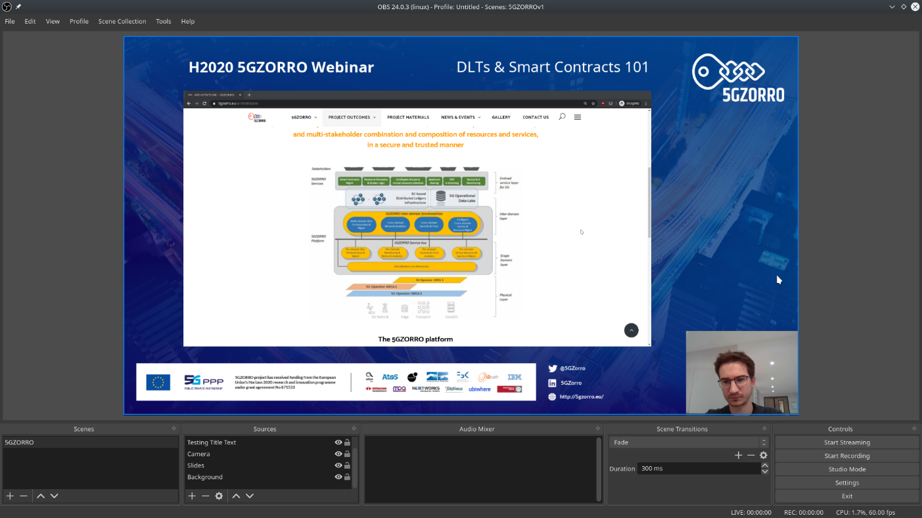

Figure – 5GZORRO Webinar Simulation

### Other Branding Material

To support 5GZORRO communication and dissemination activities, a number of other communication templates have been elaborated to establish a common project branding and image in public events.

#### Template for project presentations

In order to have a more coherent view of the 5GZORRO outcomes, a template for presentations has been elaborated, inspired to the image style of the website.



Figure - Presentation Template

#### Templates for flyers, posters, webinar

To ensure consistent branding and message, a set of templates have been produced as illustrated in the following figures, which follow the website graphics style.

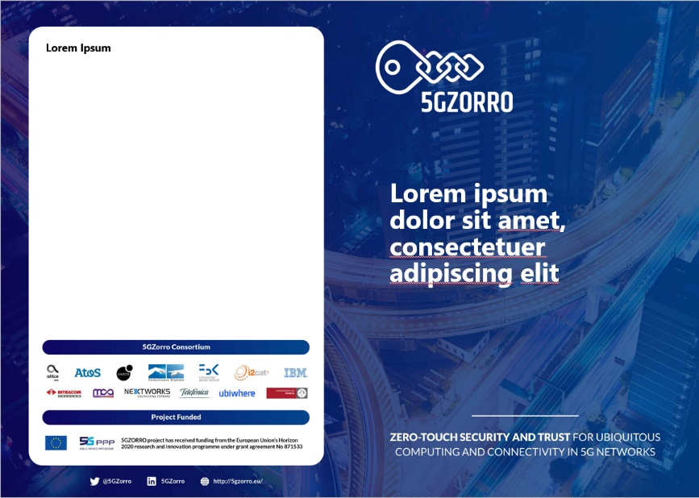

Figure - Flyer Template



Figure - Poster Template



Figure - Webinar Template

## Project Communication Material

### Flyer

A flyer describing 5GZORRO vision, use-cases and expected outcomes is an essential tool to provide information on the project to all the targeted audiences in a visually appealing manner. To be as illustrative as possible, the flyer will be composed of diagrams and limited text.

A first edition of the flyer is targeted to be published and distributed in MWC 2020, Barcelona by the end of February 2020.

Other editions or re-prints will be prepared for other event and/or workshop attended by the partners.

### Roll-up and Posters

Designing a roll-up will also be important to assist the dissemination of the project in events, seminars, conferences and workshops, mostly by partners from academia and research centres. The 5GZORRO posters will be edited to highlight key research topics, specific solutions and/or outcomes in relation to project activities and scientific publications.

A first edition of a 5GZORRO rollup is targeted to be published in Q2 2020 for use in events attended by the Consortium.

### Promotional Video

To address more dynamic means of communication, there will be outlined and created a video describing 5GZORRO overall concept, core research areas and use cases.

This video will be disseminated at events and across the digital communication channels of the project (e.g. website, social media channels etc.).

A first edition of the video is targeted to be published and announced at MWC 2020, Barcelona by the end of February 2020.

## Press Releases & News

One of the mechanisms to raise public awareness and reach the general public, industry, Telco, ICT stakeholders, opinion leaders, institutions related to 5GZORRO research is the instrument of press releases. They will be periodically issued, especially for those events where 5GZORRO activities and relevant participation is expected. News from partners’ participation in other relevant events will be published in the news section in 5GZORRO web and socials.

All partners will be invited to make diffusion through their websites/socials to make impact on their local/regional media. The initial schedule for 5GZORRO press release is reported in the table below, which aims to link issues with the major important EU and international events in which the Consortium intend to participate.

Table – Plan for 5GZORRO Press Releases

| **Date** | **Date/Event** | **Type** | **Dissemination** |
| --- | --- | --- | --- |
| 17 Feb. 2020 | 24-27 Feb. 2020  MWC2020  Barcelona | 5GZORRO Press Release pre-event – planed participation.  Save the date will be announce from mid-January 2020 | 5GZORRO Web/Socials  Partners Web/Socials  5G PPP Web/Socials  Daily activities during the MWC with news, quotes, photos and videos live from Barcelona thanks to journalists and social media managers |
| 02 Mar. 2020 | MWC2020 | 5GZORRO Press-release post-event - results | 5GZORRO Web/Socials  Partners Web/Socials  5G PPP Web/Socials |
| 20 May 2020 | 15-18 June 2020 EUCNC2020  Dubrovnik | 5GZORRO Press Release pre-event – planed participation  Save the date will announce from mid of May | 5GZORRO Web/Socials  5G PPP Web/Socials |
| 22 Jun. 2020 | EUCNC 2020 | 5GZORRO Press-release post-event - results | 5GZORRO Web/Socials  Partners Web/Socials  5G PPP Web/Socials Daily activities during the EUCNC with news, quotes, photos and videos live from Dubrovnik thanks to journalists and social media managers |
| 28 May 2020 | 18-19 June 2020 European Digital Forum  Lucca | 5GZORRO Press Release pre-event – planed participation  Save the date will be announce from end of April 2020  Organizing a 5GZORRO “physical area” to release more information on the project | 5GZORRO Web/Socials  Partners Web/Socials  5G PPP Web/Socials/ Event’s Media partners  Daily activities during the FED 2020 with news, quotes, photos and videos live from Lucca thanks to journalists and social media managers |
| 22 Jun. 2020 | European Digital Forum | 5GZORRO Press-release post-event - results | 5GZORRO Web/Socials  Partners Web/Socials  5G PPP Web/Socials/ Event’s Media partners |
| 23 Nov. 2020 | ICT 2020  Cologne | 5GZORRO Press-release post-event - results | 5GZORRO Web/Socials  Partners Web/Socials  5G PPP Web/Socials/ Event’s Media partners |
| Feb. 2021 | Feb.  MWC2021  Barcelona | 5GZORRO Press Release pre-event – planed participation  Save the date will be announce from mid-January 2021  5GZORRO Press-release post-event - results | 5GZORRO Web/Socials  Partners Web/Socials  5G PPP Web/Socials  Daily activities during the MWC with news, quotes, photos and videos live from Barcelona thanks to journalists and social media managers |
| May 2021 | June 2021 European Digital Forum  Lucca | 5GZORRO Press Release pre-event – planed participation  Save the date will be announce from end of April 2021    Organizing a 5GZORRO “physical area” to release more information on the project  5GZORRO Press-release post-event - results | 5GZORRO Web/Socials  Partners Web/Socials  5G PPP Web/Socials/ Event’s Media partners  Daily activities during the FED 2021 with news, quotes, photos and videos live from Lucca thanks to journalists and social media managers |
| May 2021 | June 2021  EUCNC 2021 | 5GZORRO Press Release pre-event – planed participation  Save the date will announce from mid of May  5GZORRO Press-release post-event - results | 5GZORRO Web/Socials  5G PPP Web/Socials |
| Jan. 2022 | Feb. 2022  MWC2022  Barcelona | 5GZORRO Press Release pre-event – planed participation  Save the date will be announce from January 2022  5GZORRO Press-release post-event - results | 5GZORRO Web/Socials  Partners Web/Socials  5G PPP Web/Socials  Daily activities during the MWC with news, quotes, photos and videos live from Barcelona thanks to journalists and social media managers |

In general, for any major conference or exhibition in which the project will participate (e.g. focused on topics in scope with 5GZORRO research like AI, ML, DLTs, security), the communication team will prepare a pre-event press release to describe activities and locations, and a post event press release reporting on results.

## Blog

To make 5GZORRO a reference influencer on zero-touch automation, spectrum sharing, AI and DLTs for 5G, the Consortium has planned to elaborate a plan for periodic blog posting on specific topics related to the project agenda.

A plan for a consistent and fair contribution of blog posts for 2020 is reported in the following table.

Table – Plan for blog post contributions in 2020

|  |  |  |
| --- | --- | --- |
| **Date** | **Blog Post Topic** | **Partners** |
| March 2020 | 5GZORRO challenges, motivation and project | NXW, i2CAT |
| May 2020 | Standardization and Open Source Initiatives for 5G | TID |
| July 2020 | 5GZORRO use cases | Altice Labs |
| September 2020 | On benefits of DLTs as an enabler for trust-less multi-stakeholder interaction in a marketplace. | Ubiwhere |
| November 2020 | DLT use cases | BARTR |
| January 2021 | 5GZORRO architecture | Atos Spain |
| March 2021 | Challenges of creating a vCDN and some technical insights. | ICOM |
| May 2021 | Spectrum sharing and regulation | MCA |
| July 2021 | Security and Trust Orchestration | UMU |
| September 2021 | 5G Operational data lakes | IBM |
| November 2021 | To be confirmed (TBC) | TBC |
| January 2022 | TBC | TBC |
| March 2022 | TBC | TBC |

Even though specific subjects have already been identified for some of the targeted months, this scheduling will be in constant updates, as the project evolves.

Although the plan is to have a blogpost bi-monthly, the partners are encouraged to submit blogpost as the work progresses.

## Newsletter

Newsletters will be used to periodically highlight the achievements from the project; and at the same time to report different dissemination activities: Technical news, Blog posts, Papers published, Upcoming and Past events.

The newsletters will be published from March 2020 onwards, targeting 4 issues per year as per following calendar:

* 2020: NL#1/March2020, NL#2/June2020, NL#3/Sept2020, NL#4/Dec2020
* 2021: NL#5/March2021, NL#6/June2021, NL#7/Sept2021, NL#8/Dec2021
* 2022: NL#9/March2022, NL#10/May2022

These newsletters will include relevant information from last three months, including: contributions in workshops and congress, pictures, videos, publications, papers related to the project, dissemination actions and links to blog posts contents.

# Dissemination Plan

Dissemination is a key part of the achievement of the 5GZORRO impact. It will comprise various forms for presenting and discussion the project’s solutions and approaches, including participation in fairs, summits, workshops, and conferences; production of journal papers; also, organization of dedicated events through which to approach the large professional network and digital communities of 5G stakeholders.

The types of dissemination activities selected by the Consortium to execute dissemination of 5GZORRO outcomes can be listed in:

* **Participation, talks and submission of papers in scientific conferences**. Forums of particular interest include those working on
  + *Virtualization of Networks*: IEEE Conference on Network Function Virtualization and Software Defined Networks (IEEE NFV-SDN), IEEE International Conference on Network Softwarization (NetSoft), IEEE Global Communications Conference (Globecom), European Conference on Networks and Communications (EUCNC), IEEE International Conference on Communications (ICC), International Symposium on Mobile Ad Hoc Networking and Computing (MobiHoc);
  + *Cybersecurity, Blockchains, DLTs*: IEEE International Conference on Blockchain and Cryptocurrency, Cybersecurity European Forum, International Conference on Security and Cryptography (SECRYPT), Information Security and Privacy Conference (IFIPSec), European Symposium on Research in Computer Security (ESORICS);
  + *AI and Zero-touch automation*: Zero Touch Automation Congress, IEEE Big Data Congress.
* **Production of scientific papers in international reference journals and magazines**, among which are of particular interest:
  + IEEE/ACM Transactions on Networking, IEEE Transactions on Network and Service Management (TNSM), IEEE Communications Magazine, IEEE Transactions on Network and Service Management, IEEE Transactions on Industrial Informatics, IEEE Communication Magazine, International Journal of Computer and Telecommunications Networking
* **Participation to industry events with project activities and demos**. The Consortium has put in its radar events like Mobile World Congress -Barcelona (MWC), Blockchain Summit, SDN & NFV World Congress, IEEE 5G World Forum, Open Networking Summit (ONS), Open Source Summit, European Digital Forum, 5GForum Malaga, KubeCon, Zero Touch Automation Congress, etc.
* **Organization of 5GZORRO events**, like workshops, conference sessions, webinars dealing with security, trust and automation in 5G. Some of the topics that can be covered during these activities include:
  + Cross domain security and trust
  + Zero touch automation
  + Smart Contracts
  + Machine Learning (ML)
  + Distributed Ledger Technologies
  + 5G service and network management platforms
  + Big data & Artificial Intelligence and edge technologies
  + Standardization

Table 3 lists a first strategic calendar of events which have been identified by the Consortium and by the individual partners for a potential presence of 5GZORRO representatives for dissemination activities (presentations, invited talks, workshops, booths for demos, etc.). It is expected that it will help Consortium to select and create a strong network among the technological and scientific community at European and international level, and to convey relevant contents about the project development and outcomes. The following table does not represent the exact calendar of planned attendances, which instead will be decided based on the availability of results and the progress with workplan. Moreover, detailed information about partner’s participation in events is highlighted in section 3.3.

Table – Events with potential 5GZORRO presence with dissemination activities

| **Event Name** | **Date/Place** | **Topics/Activity proposed** | **Website** |
| --- | --- | --- | --- |
| **The European 5G Conference** | 29-30 Jan 2020  Brussels | Brussels’ leading meeting place for discussion on 5G policy. Topics:  Key Commission representatives on direction and priorities to deliver the 5G vision in Europe 5G rollout - the experience to date, deployment, lessons learned; Security challenges of 5G; Key outcomes relating to 5G spectrum at WRC-19 and to examine the candidate bands that have been identified for WRC-23; Path towards a 'post 5G world', and the possible shape of B5G (Beyond 5G) and 6G | [https://5gconference.eu/](https://5gconference.eu/?utm_campaign=444759_EU%205G%20early%20bird%20reminder&utm_medium=dotdigital&utm_source=Forum%20Europe&dm_i=4SEG%2C9J6F%2CEFWD2%2C107X2%2C1) |
| **MWC 2020** | 24-27 Feb. 2020 Barcelona | Video with project introduction to be played in loop at multiple booths (at MobileWorldCapital and i2CAT);  Flyer to multiple booths (5G PPP, MobileWorldCapital and i2CAT);  Press release | <https://www.mwcbarcelona.com/> |
| **IEEE/IFIP Network Operations and Management Symposium** | 20-24 April 2020  Budapest, Hungary | Management in the Age of Softwarization and Artificial Intelligence | <https://noms2020.ieee-noms.org/> |
| **5GForum** | 6-7 May.  Málaga | Spanish national event around the different applications of the 5G, like: 5G Deployment.  Artificial Intelligence; Big Data  Speech/Panel discussion with European opinion leaders; Attendance and networking to spread 5GZORRO project objectives; Press release | <https://www.5gforum.es/> |
| **17th European Digital Forum** | 10-11-12 June Lucca | Broadcasting/Broadband/OTT New technologies Conference  Booth for meetings and awareness exploitation  Video with project’s objectives and UCs description to be played in loop  Dissemination materials  Flyer, Roll-up  Speech/Panel discussion with European opinion leaders  Workshop crossing with other 5G EU projects  Press release | [www.forumeuropeo.tv/](http://www.forumeuropeo.tv/) |
| **EUCNC2020** | 15-18 June, Dubrovnik, Croatia | Positioning technical paper about 5GZORRO.  On 5G PPP Booth video with project’s objectives and UCs description and Flyers; Press release | [www.eucnc.eu/](http://www.eucnc.eu/) |
| **Malta AI & Blockchain Summit** | June 2020 Malta | Tentative 5GZORRO presentation, by MCA partner | <https://maltablockchainsummit.com/> |
| **SECRYPT** | 8-10 July 2020  Paris | SECRYPT, part of ICETE, the 17th International Joint Conference on e-Business and Telecommunications.  SECRYPT is an annual international conference covering research in information and communication security; Attendance, roundtable and networking to spread 5GZORRO project objectives; Press release | <http://www.secrypt.icete.org/> |
| **IEEE PIMRC 2020** | 31 August-3 September 2020  London | One of the two major conferences of the IEEE Communications Society (ComSoc) in the field of wireless communications and networking.  Track 3: Practical and Experimental Systems (paper submission)  Track 4: Applications and Business (paper submission) | <https://pimrc2020.ieee-pimrc.org/> |
| **BRAINS 2020** | 28-30 Sept. 2020  Paris | 2nd Conference on Blockchain Research & Applications for Innovative Networks and Services  Technically sponsored by IEEE ComSoc; in-cooperation with ACM SIGAPP  Topics of interest:  Fundamentals of Blockchain and DLT; Performance and security; Decentralized Apps, Smart contracts and chain code; Application and service cases of DLT and Smart-Contracts. | <https://brains.dnac.org/call-for-papers/> |
| **Open Networking & Edge Summit Europe** | 30 Sept-1 Oct 2020  Antwerp, Belgium | Open networking event on Edge Computing, Edge Cloud & IoT.  Collaborative development and innovation across enterprises, service providers/Telco and cloud providers.  Deep focus on Technical, Architectural and Business Discussions in the areas of Open Networking & AI/ML-enabled use cases for 5G, IoT, Edge and Enterprise deployment.  Targeted discussions on Edge/IoT Frameworks and Blueprints across Manufacturing, Retail, Oil and Gas, Transportation and Telco Edge cloud.  Press release | <https://events.linuxfoundation.org/open-networking-edge-summit-europe/> |
| **DELTA Summit** | October 2020 Malta | Tentative 5GZORRO presentation, by MCA partner | <https://delta-summit.com/> |
| **Open Source Summit + Embedded Linux Conference Europe** | 26-28 Oct 2020  Du IEEE Globecom 2020 Dublin, Ireland | Details Available later in 2020 | <https://events19.linuxfoundation.org/upcoming-events/> |
| **IEEE GLOBECOM 2020** | 7-11 Dec. 2020  Xinyi District, Taipei City, Taiwan | Details Available later in 2020 |  |
| **Cybersecurity Standardization Conference 2021** | Feb 2021 | The conference will discuss the challenges in the standardisation landscape for Cybersecurity in light of the EU Cybersecurity Act. | <https://www.enisa.europa.eu/events/cybersecurity_standardisation_2020> |
| **6th MENA Spectrum Management Conference** | Feb. 2021 | Networking, Partners involved in Spectrum Management | <https://mena-spectrum.com/> |
| **MWC2021** | Feb. 2021 Barcelona | Video with project’s UC description to be played at multiple booths at MobileWorldCapital and i2CAT booths  Flyer at MobileWorldCapital, i2CAT, 5G PPP booths  Roll-up  ICOM and UW may have promotional material at their booth | [www.mwcbarcelona.com/](http://www.mwcbarcelona.com/) |
| **AI&Big Data Expo Global 2021** | Mar. 2021 | The leading Artificial Intelligence & Big Data Conference & Exhibition, will showcase the most cutting-edge technologies. Topics include Business Intelligence, Deep Learning, Machine Learning, AI Algorithms, Data & Analytics, Virtual Assistants & Chatbots | <https://www.ai-expo.net/global/> |
| **Blockchain Expo 2021** | Exploring the key industries that are set to be disrupted the most by this new technology, including; legal sectors, retail, financial services, healthcare, insurance, energy, music, government, real estate. | <https://blockchain-expo.com/global/> |
| **Cyber Security & Cloud Expo** | Key topics examined include: security, scalability, best practice for CISO’s, staffing issues, providing ROI, cloud, network defence, digital identity, automation, emerging tech, threat detection and landscapes, DDoS, malware and the human factor. | <https://www.cybersecuritycloudexpo.com/global/> |
| **Blockchain Week Rome 2021** | 17-21 Mar. 2021  Rome | Blockchain experts and companies  17-18-19 Blockchain course 20-21 Blockchain Summit | <https://www.blockchainweekrome.com/> |
| **IEEE BIGDATASERVICE 2021** | Apr. 2021 | The Sixth IEEE International Conference on Big Data Computing Service and Machine Learning Applications | <https://www.big-dataservice.net/> |
| **Open Networking & Edge Summit North America** | April 2021 | Details Available Late 2020 | <https://events19.linuxfoundation.org/upcoming-events/> |
| **IFIP/IEEE International Symposium on Integrated Network Management** | April 2021 | Details not yet available |  |
| **IEEE International Conference on Blockchain and Cryptocurrency** | May 2021 | ICBC 2020 is the primary forum for the technical exchange of the latest research and innovation, regulation, policies, standards, and applications in the exciting and emerging area of blockchain and cryptocurrency. | <https://icbc2020.ieee-icbc.org/> |
| **5GForum** | May, 2021 Málaga Spain | Spanish national event around the different applications of the 5G | <https://www.5gforum.es/> |
| **IFIP SEC 2021** | May 2021 | 35th IFIP TC-11 SEC 2020 International Information Security and Privacy Conference | <https://sec2020.um.si/> |
| **IEEE ICC2021**  **CLEEN2021** | June 2021 | Details not yet available | <https://icc2020.ieee-icc.org/>  Workshop: <https://5g-ppp.eu/cleen2020/> |
| **18th European Digital Forum** | June, 2021  Lucca, Italy | Details not yet available | [www.forumeuropeo.tv/](http://www.forumeuropeo.tv/) |
| **EUCNC2021** | June, 2021 | Details not yet available | [www.eucnc.eu/](http://www.eucnc.eu/) |
| **BRAINS 2021** | Sept. 2021 Paris | 3nd Conference on Blockchain Research & Applications for Innovative Networks and Services. Technically sponsored by IEEE ComSoc; in cooperation with ACM SIGAPP | <https://brains.dnac.org> |
| **Open Networking & Edge Summit Europe** | 30 Sept-1 Oct, 2020Antwerp, Belgium | Industry’s premier open networking event that covers Edge Computing, Edge Cloud & IoT. |  |
| **Layer123 World Congress 2020: Service Evolution Beyond SDN and NFV** | Oct. 2021  The Hague, Netherlands | Details not yet available | <https://events.layer123.com/sdn> |
| **MWC 2022** | Feb. 2022  Barcelona | Details not yet available | [www.mwcbarcelona.com/](http://www.mwcbarcelona.com/) |
| **AI&Big Data Expo Global 2021** | Mar. 2022 | Details not yet available | <https://www.ai-expo.net/global/> |
| **Blockchain Expo** | Details not yet available | <https://blockchain-expo.com/global/> |
| **Cyber Security & Cloud Expo** | Details not yet available | <https://www.cybersecuritycloudexpo.com/global/> |
| **5G Expo** | Details not yet available | <https://5gexpo.net/global/> |

## Open access policy

Open access (OA) refers to the practice of providing, free of charge to any user, online access to: all peer-reviewed scientific information and all the research data. Specific information about the use of open access is in article 29 of the GA.

To ensure open access, The Consortium will create a 5GZORRO repository in Zenodo which will contain the project material, open access publications and pre-prints (not covered by copyright).

All public deliverables will be published in the project webpage, the Zenodo community and will also be shared with the 5G PPP community.

## Collaboration within 5G PPP and other projects

The 5GZORRO Consortium has also planned to play an active role in the various activities of 5G PPP working Groups and with other 5G PPP projects of the Phase 3.

In particular, 5GZORRO intends to participate to some key Working Groups of the 5G PPP and 5G Infrastructure Association through designated representative partners as briefly reported in the following Table 4.

Table – 5GZORRO collaborations within 5G PPP area

|  |  |  |  |
| --- | --- | --- | --- |
| **Area** | **Working Group** | **5GZORRO representative** | **Main activities** |
| **5G PPP** | **Steering Board** | i2CAT (S. Siddiqui)–PC | * Main program coordination * Annual Program report * EUCNC / MWC coordinated participation |
| **5G PPP** | **Technical Board** | NXW (G. Carrozzo)–TM | * Project cartography * Program and project KPIs analysis and assessment * Golden Nuggets * Cross-project technical coordination * Annual Program report * EUCNC / MWC coordinated participation |
| **5G PPP** | **5G PPP COMMS** | CODI | * Coordinated communication initiatives |
| **5G PPP** | **Architecture** | ALB | * Discussion on new architecture whitepaper |
| **5G PPP** | **Software Networks (SDN/NFV)** | UW, IBM | * Discussion on new whitepaper * Workshops at EUCNC and similar conferences |
| **5G IA** | **Spectrum WG** | I2CAT | * Discussion on spectrum sharing |
| **5G IA** | **Security** | UMU | * Discussion on new Security whitepaper * Workshops at EUCNC and similar conferences |
| **5G IA** | **Vision and Societal Challenges** | NXW | * Periodic conference calls |
| **Networld 2020** | **SME WG** | NXW | * EUCNC / MWC coordinated participation for SMEs * SME brokerage and promotion within 5G PPP |

In addition, contacts and liaisons with other projects are planned, particularly with those funded in the same H2020 Call ICT-20-2019.

More specifically, liaisons via joint partners will be possible with the projects: **LOCUS** (<https://www.locus-project.eu/>, bridging partners NXW and IBM), **5GCLARITY** (<https://www.5gclarity.com/>, bridging partners NXW and IBM), **5G-COMPLETE** (<https://5gcomplete.eu/>, bridging partners NXW).

## Individual dissemination plans

All the partners in 5GZORRO Consortium have defined individual plans for dissemination of the project’s findings and outcomes. These are briefly reported in the following.

### Altice Labs (ALTICE)

Altice Labs, being close to a telecommunications group, will contribute to the dissemination of 5GZORRO’s results by the following actions:

* Organize and participate in internal Knowledge Share (KShare) sessions, at multiple levels (business unit, company and group), pushing through our innovation process the project’s findings and relevant results;
* Evaluate, through the execution of Proof-of-Concept (PoC) projects, the relevance of the addressed technologies and obtained results, in order to enrich our product and services portfolio;
* Give back to the open-source community software that is developed for the project;
* Participate in the team’s efforts to publish results (papers, blogs, etc.)

### ATOS Spain (ATOS)

ATOS will support communication and dissemination activities via on-line communication (social networks, press media, website, etc.), exploiting synergies with already running research projects and support all dissemination activities carried out by the project. It will also contribute with the elaboration of technical papers to be submitted to relevant Call for Papers for conferences and Journals. It will help with the objectives for dissemination by making contributions to selected open source communities, such as Open Source MANO, in which Atos is member of its Technical Steering Committee.

Atos will also provide the corporative communication and marketing structures in order to maximize the project reach and knowledge. Atos Research and Innovation counts with a Marketing and Communication department (ARI Marcomm) that provides communication and dissemination services to 5GZORRO. The group has direct contact with Iberia and Global Marketing department to distribute Press Releases and specific scientific and general content for the corporate website, blog and social media channels. In addition to this strategic resources, ARI Marcomm uses multiple tools such as the internal newsletter, the Atos Thought Leadership Blog and the organization of events such as the Atos Digital Show. ARI Marcomm also has a professional design team that produces graphical material, commercial videos and graphical identity for projects at through internal (Atos research mailing lists, ARI public info in Zen space and ARI newsletter, Atos Research and Innovation Booklet) and external channels(ARI Marcomm social Media, Atos Spain Social Media, Event Radar, ARI Digital Show, ARI Booklet, Potential participation in industrial events, Atos Thought Leadership Blog, Newsroom).

### BARTR HOLDINGS Ltd (BARTR)

BARTR will contribute to the dissemination objectives of 5GZORRO in a number of ways using digital and more traditional lines of communications as well as established events. Using our own internal communication channels of our social media feeds to highlight and champion our own and other partners involvements within the project as well as extensive internal coverage within our news section of our website. As well as this our team will look to make selective contributions to open source communities. We’re in the process of agreeing appearances at relevant events, and potential appearances on podcasts / interviews on relevant blogs / journals to help disseminate the progress of the project within the 5g and blockchain communities we are part of in the UK. We will look to use presentations and videos to summarise the work. Finally, we're looking to work with the relevant counterparts within the project to engage with the UK media and tech press / journalists to highlight the progress and achievements of the project as a whole from a Bartr perspective and in a co-ordinated way for the project as a whole.

### Communicare Digitale (CODI)

CODI will primarily focus on communication activities supporting the Consortium activities for 5GZORRO with: professional graphic design, video production, journalism, event organization structure, elaboration of press and news releases, articles and interviews, social media engagement campaigns. CODI will contribute to the dissemination objectives of 5GZORRO by amplifying trough the web and socials, 5GZORRO partners’ participation in talks, roundtables, panels of discussion. CODI will also support in the organization and promotion of at least two workshops and/or webinars before the end of the project. A precise calendar of this activity will be implemented from M11.

### Fondazione Bruno Kessler (FBK)

FBK is committed to supporting all communication and dissemination activities carried out by itself and the other partners of the project via FBK social media channels (Twitter, LinkedIn, Facebook). FBK plans to disseminate the results from the project activities to top scientific conferences, journals, and magazines. Besides, FBK plans to disseminate the activities and results of the project in events with local stakeholders, as well as the Mobile World Congress.

### Fundació I2CAT (i2CAT)

I2CAT will contribute to the dissemination objectives of 5GZORRO by producing publications of the results, in international conferences (ICC, Globecom, EUCNC, etc.) and peer reviewed magazines and journals including special issues in selected journals as: IEEE Transactions, IEEE ComMag or TNC. i2CAT will also contribute to the dissemination of the project by presenting it at the MWC 2020. This will be achieved through an introductory video and/or presentation based on the main objectives and challenges of 5GZORRO i2CAT and MobileWorldCapital booths. The following year i2CAT will aim to disseminate 5GZORRO progress with possibility of a demo based on initial results of the 5GZORRO project, at the MWC2021. Another way in which i2cat will help with the objectives of the project dissemination, is by making contributions to selected open source communities. The ones that seem to align better with the 5GZORRO project objectives are ETSI open-source MANO and ETSI Zero Touch Network and Service Management (ZSM).

### IBM Israel (IBM)

IBMwill drive effort into expanding the reach of the outcomes of the 5GZORRO project through the participation and submission of papers in scientific conferences on Virtualization of Networks and Cybersecurity and by getting involved in other events within this industry.

IBM plans to disseminate project findings in academia through its extensive university relationships and academic publishing. It will reach the public by sharing the updates of the project through social media channels, the institutional website and other publications.

### Intracom Telecom (ICOM)

ICOM will contribute to the dissemination objectives of 5GZORRO by participating and communicating project material in international events (MWC). Moreover, Intracom plans to take part in the submission and presentation of papers related to the 5GZORRO architecture solution. In addition, ICOM plans to publish papers on the architecture and experimental results of the vCDN network slice extension solution at scientific Pan-European conferences (e.g. EUCNC). Finally, ICOM will examine relevant contribution to the ETSI Multi-access Edge Computing (MEC) ISG.

### Malta Communications Authority (MCA)

MCAwill contribute to the communication and dissemination of 5GZORRO via its online presence (website, social media) and by attending key events, both in Malta and at a European level, supporting the promotion of 5GZORRO results. MCA will also contribute to the dissemination of the project objectives and results by showcasing and promoting 5GZORRO activities relevant to the area of spectrum management in the networks where it participates, including the Body of European Regulators for Electronic Communications (BEREC), the Radio Spectrum Policy Group (RSPG) and relevant working groups within the International Telecommunications Union (ITU). Where possible, the MCA will complement informal networking awareness raising activities with presentations / break-out information sessions. The MCA will also organise an information session for Maltese academia, particularly within the University of Malta’s Centre for Distributed Ledger Technologies, on the application of blockchain technologies in spectrum management.

MCA is targeting the following events: MWC 2020, Malta AI & Blockchain Summit (June 2020), DELTA Summit (October 2020), raising also awareness across relevant networks (BEREC, RSPG, ITU), by promoting objectives and results relevant to the efficient and effective use of spectrum. In parallel, Q4 2020 and Q4 2021, MCA will organise an information session for members of the Centre for Distributed Ledger Technologies, within the University of Malta.

### Nextworks (NXW)

NXW, as an SME, plans to focus their dissemination strategy through 5GZORRO to consolidate relationships with the 5G industrial community and establish new links with the emerging community on AI and DLT. The planned actions consist of contributions to joint publications in top-ranked journals and conferences to report on project results (both architecture design of 5G LTE networks and prototypes of 5GZORRO platform and solutions integrated with use cases), demonstrations in top-level exhibitions and conferences, liaisons with open source communities (e.g. ETSI OSM, Linux Foundation Deep Learning and Networking initiative). Another important area of contribution would be to the strategic actions carried out within 5G PPP Working groups, the 5G Infrastructure Association and Networld 2020 ETP.

Nextworks’ goals are to attend and/or participate in different events such as MWC 2020-2022, EUCNC 2020-2022 and ICT2020 Event, doing also 5GZORRO live demonstrations in events such as LAYER123 WORLD CONGRESS 2020 and KubeCon + Cloud NativeCon. Furthermore, NXW plans to contribute to both to ETSI OSM and ETSI ZSM WGs, committing also to the production of different technical papers.

### Telefonica I+D (TID)

TID intends to disseminate the project research results in the Telefónica wider ecosystem: (i) business units, with the goal of promoting the results and ideas inside the group strategic roadmaps; (ii) providers, to influence the products and services supplied to the Telefónica Group according with the results of the project; (iii) customers, building awareness about the opportunities that cognitive technologies bring, and the position of Telefónica among the leaders in network transformation; (iv) the ICT industry at large

The planned activities include:

* Internal evangelization, through the dissemination of the main project results, across the entire organization, using Telefónica Excellence School, internal communication channels (corporate Facebook, ThinkBig blog, etc.), Telefónica Design Councils and TID demonstration facilities.
* Presentation of the main innovations developed in the project to the entrepreneurship initiatives of Telefónica (Wayra, Amerigo and Telefónica Open Future) with the goal of facilitating their application by the start-ups nurtured by these initiatives.
* Presentations and demonstrations at the industrial events TID is regularly present, and those conferences where TID experts are invited to talk.
* Conferences, such as IEEE NFV-SDN, NetSoft, or Globecom

Industry events, such as the Mobile World Congress, the OIF, the SDN&NFV World Congress, and the MPLS and SDN World Congress.

### Ubiwhere

UW taking the role of Innovation Manager (IM) and WP6 leader, will ensure all 5GZORRO partners are working closely to achieve the project’s overarching goals and a successful exploitation of all innovation brought forth. Aligned with this IM role, Ubiwhere will follow closely the latest advancements of all 5GZORRO key areas (scientifically and at industry-level), identifying areas and businesses where such innovation may be disruptive to specific areas and stakeholders’ business model. Doing so, Ubiwhere will make sure all external communication, dissemination and standardisation activities are (I) correctly undertaken, (ii) targets the right stakeholders and verticals and (iii) there is clarity in the overall mission and vision of the project.

Aligned with the core values of the company and flagship products in the Telco area, such as the ever-evolving 5G Neutral Hosting platform (https://smartlamppost.com), Ubiwhere is committed to leverage its presence in industry-leading events like Smart City Expo and Mobile World Congress to disseminate the project’s findings at its own booth. Furthermore, Ubiwhere is committed to attend and actively participate in events such as ICT 2020, EUCNC 2020-2022 and TM Forum Live 2020 disseminating 5GZORRO’s activities and outcomes whenever possible.

### Univ. De Murcia (UMU)

The University of Murcia is a Spanish academic institution with previous experience in the development, communication and dissemination tasks of other relevant European projects in the 5G, cybersecurity, and network and service management fields.

UMU team will support and enhance the communication and dissemination activities carried out by itself or together with other partners using its institutional communication channels, such as its website, social networks (+150K followers) and media (TV, press, etc.)

Specifically for the 5GZORRO project, the University of Murcia will contribute to the dissemination and communication of the project through the publication of position or research papers of high scientific level in different venues including conferences, journals and magazines. Based on these publications, at least two PhDs will be conducted. UMU will also support the project dissemination by attending and doing presentations about the project in relevant research and innovation events.

UMU team plans to participate through 5GZORRO in 5GForum-Malaga (Spanish national event on different applications of the 5G), EuCNC 2020 and Open Networking & Edge Summit Europe. Moreover, UMU plans to contribute to 5G IA Security Working Groups and the Spanish Network of Excellence on Cybersecurity Research (RENIC), besides of the support and contribution to joint demos at international events.

Besides, the obtained results and knowledge will be transferred to private companies and public organizations through already established collaboration agreements and possible new ones that may appear as part of the collaboration of the UMU team in 5GZORRO and other 5G-related national and international research and innovation projects.

Finally, the University of Murcia team will also include the main achievements in 5GZORRO to its educational and training activities at the Bachelor, Master and PhD levels, using 5GZORRO as an example of the application of new technologies in novel research and innovation fields.

# Plans towards Standards and Open Source communities

Even though the project is still in its early days and the technical architecture and components are under definition, the 5GZORRO core design principles and reference technologies are well-defined. Therefore, it has been possible to define a tentative plan of contributions to target SDOs/SSOs (Standards Developing Organization / Standards Setting Organization) as listed in Table 5 below. Different types of contributions are envisioned, ranging from involvement in technical discussions and sharing 5GZORRO results, to active contribution to standardisation efforts and/or open-source projects and communities.

Table – SDOs/SSOs & Open-source communities / projects

|  |  |  |
| --- | --- | --- |
| **Working Groups / Open-source projects** | **Active Partners** | **Expected Contributions** |
| **ECSO WG3: Sectoral demand (Telecom, Media and Content)** | UMU, ATOS | Participation in project meetings focusing on cyber capacity building and business development. |
| **ECSO WG6 – SRIA and Cyber Security Technologies** | UMU, ATOS, TID, i2CAT | Active collaboration in the technical papers on Blockchain and on 5G and communication technologies and vision paper cyber security priorities towards Horizon Europe (ECSO 2021-2027 vision) |
| **ETSI Experiential Networked Intelligence (ENI)** | TID, BTL, ALB, NXW | Definition and evolution of the Cognitive Network Management architecture |
| **ETSI Zero touch network & Service Management**  **(ZSM)** | TID, BTL, ALB, i2CAT | Contribute to progress on ZSM architecture and interface specifications. Proposal of scenarios of interaction with DLTs for distributed service management. |
| **ETSI Permissioned Distributed Ledger (PDL) ISG** | TID, BTL, ALB | Demonstration of telecom-related Smart Contracts and other PDL-supported assets. Standardisation of distributed ledger interfaces for network-hosted applications. |
| **ETSI NFV ISG** | TID, ALB, NXW, UW | Evolution of the MANO architecture beyond 5G, support of heterogeneous virtualization infrastructures (incl. containers, scenarios of interaction with DLTs for distributed NFV attestation and VNF supply chain trust |
| **ETSI Multi-access Edge Computing** | ICOM, UW | Evolution of the ETSI MEC architecture beyond 5G, support for opportunistic and automated service migration, offloading and network slice extensions across the heterogeneous edge infrastructures. |
| **AIOTI DLT WG** | UW, ICOM | ICOM and UW and AIOTI members, following closely also the DLT WG. Whenever there is a chance, these partners will disseminate the project’s findings with other peers, in such a context. Findings and results of different Use Cases may be shared, such as achieved KPIs, tech stack used as relevant input. |
| **Internet Research Task Force (IRTF) and the Internet Engineering Task Force** | TID, NXW, i2CAT, UMU | Contributions are expected related with the network management, in particular regarding self-operating and self-managed networks in multi-tenant and multi-stakeholder scenarios as well as regarding the importance of trust analytics in these scenarios |
| **ETSI OSM community** | i2CAT, TID, ATOS, NXW, UW | Support and contribute to the development roadmap of OSM by integrating heterogeneous virtualization infrastructures, support for containers (under planning for next OSM releases), mechanisms for NFV attestation and VNF supply chain trust. |
| **Ethereum Development Communities (different Working Groups)** | BARTR, i2Cat, UW | BARTR, as blockchain and smart contracts expert, will closely follow Ethereum’s different Working Groups. Once the project matures and a there is a clear architecture defined, specific Working Groups may be better identified and targeted. |
| **Hyperledger Development - Telecom Special Interest Group (ISG)** | BARTR, i2Cat, UW | BARTR, together with i2Cat and UW, and aligned with the objectives of Use Cases 1 and 2, will follow closely the Telecom ISG, contributing back to the community with use cases’ findings and results. 5GZORRO is an innovative project when It comes to the intertwining of DLTs and Telecom architecture, so the consortium hopes to actively contribute with relevant findings to the industry’s leader on Permissioned Blockchains. |

Furthermore, collaborations with other initiatives will be also pursued, like for example:

* **Spanish Network of Excellence on Cybersecurity Research (RENIC),** via UMU partner, for topics related to end-to-end security and trust
* **International Telecommunications Union (ITU), European Conference of Postal and Telecommunications Administrations (CEPT), Radio Spectrum Policy Group (RSPG), European Radio Spectrum Committee (RSC),** via MCA partner for topics related to the efficient use of spectrum and sharing of infrastructure.

# Conclusions

This deliverable reports on the planned communication and dissemination activities to be undertaken by all partners. The aim of these plans is to maximize the project impact by targeting key communities for dissemination and communication, contributing to standardization bodies working on topics relevant for 5GZORRO research and interacting with important open source projects in which 5GZORRO contributions might be possibly promoted.

This document only outlines plans. Future deliverables (D6.2 and D6.3) will report back on the actual achievements in terms of dissemination, communication and standardization. As technical work progresses, the plans presented in this document will also evolve, whenever needed, to ensure an effective and coherent dissemination of results.

# Abbreviations and Definitions

## Abbreviations

|  |  |
| --- | --- |
| **5G IA** | 5G Infrastructure Association |
| **5G PPP WGS** | 5G PPP Work Groups |
| **AI** | Artificial Intelligence |
| **CA** | Consortium Agreement |
| **DLT** | Distributed Ledger Technologies |
| **DMP** | Data Management Plan |
| **DoA** | Description of Action |
| **EC** | European Commission |
| **ECGA** | EC Grant Agreement |
| **IM** | Innovation Manager |
| **IPR** | Intellectual Property Rights |
| **ML** | Machine Learning |
| **MNO** | Mobile Network Operator |
| **PPP** | Public Private partnership |
| **NFV** | Network Function Virtualization |
| **PPR** | Project’s Progress Report |
| **SDN** | Software Defined Networking |
| **SDO** | Standard Developing Organization |
| **SME** | Small Medium Enterprise |
| **SSO** | Standards Setting Organization |
| **WG** | Working Group |
| **WP** | Work Package |

## Definitions

No definitions are introduced in this document.

**<END OF DOCUMENT>**